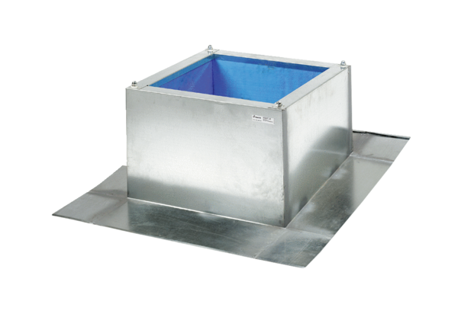Roof socket for corrugated and trapezoidal roofs SOWT 35Packing unit: 1 pieceRange: C
Article number: 0093.0987Manufacturer: MAICO

