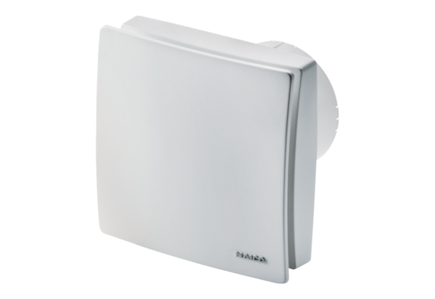Small room fan ECA 100 ipro BPacking unit: 1 pieceRange: A
Article number: 0084.0204Manufacturer: MAICO

