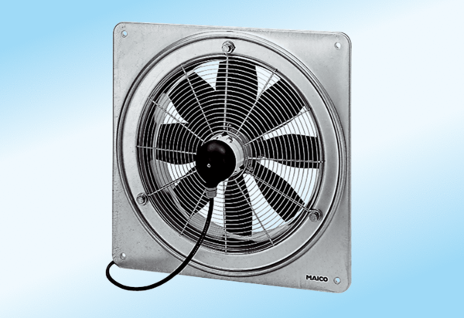Axial wall fan DZQ 45/6 A-ExPacking unit: 1 pieceRange: C
Article number: 0083.0780Manufacturer: MAICO

