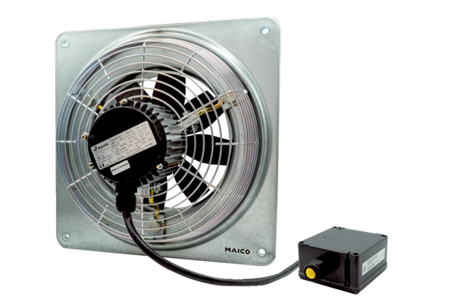Axial wall fan DZQ 40/4 B Ex ePacking unit: 1 pieceRange: C
Article number: 0083.0181Manufacturer: MAICO

