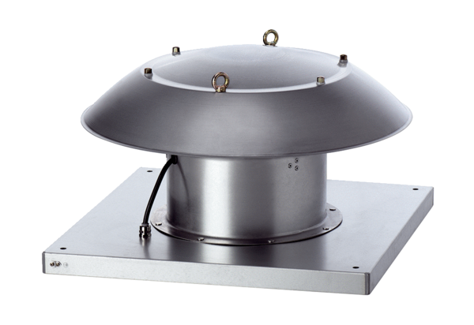Axial roof fan DZD 50/6 B Ex ePacking unit: 1 pieceRange: C
Article number: 0087.0806Manufacturer: MAICO

