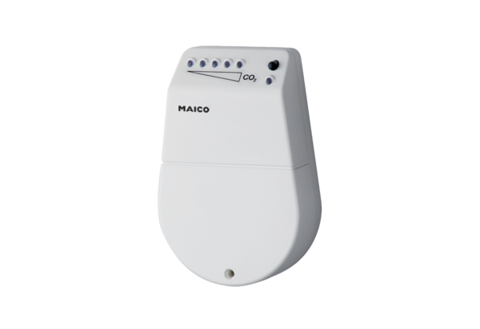CO2 sensor SKDPacking unit: 1 pieceRange: C
Article number: 0157.0345Manufacturer: MAICO

