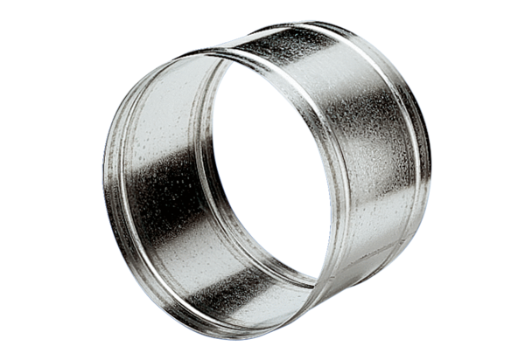Extension sleeve VH 20Packing unit: 1 pieceRange: C
Article number: 0055.0030Manufacturer: MAICO

