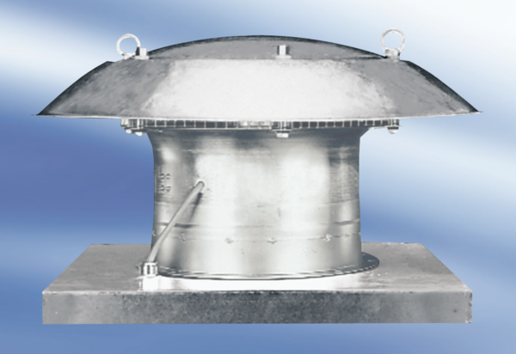Axial roof fan DZD35-4APacking unit: 1 pieceRange:
Article number: 0087.0418Manufacturer: MAICO

