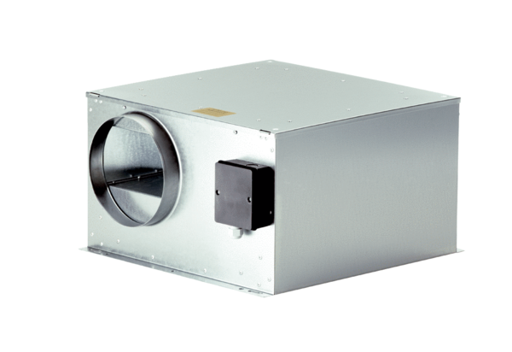Sound-insulated ventilation box ECR-A 25/31Packing unit: 1 pieceRange: C
Article number: 0080.0568Manufacturer: MAICO

