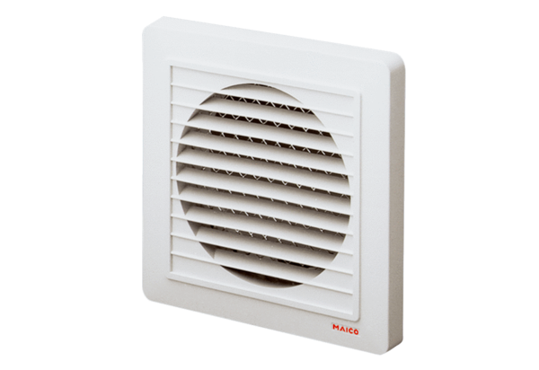External grille SG 15Packing unit: 1 pieceRange: A
Article number: 0059.0904Manufacturer: MAICO

