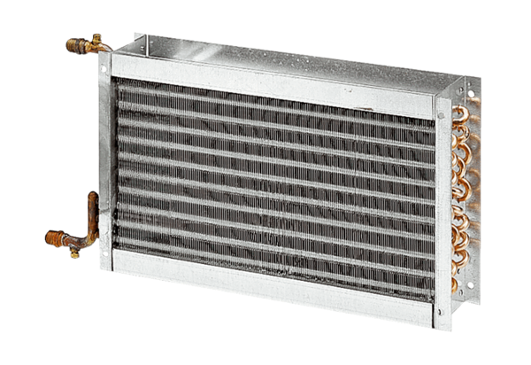Water air heater WHP 35-43Packing unit: 1 pieceRange: D
Article number: 0082.0115Manufacturer: MAICO

