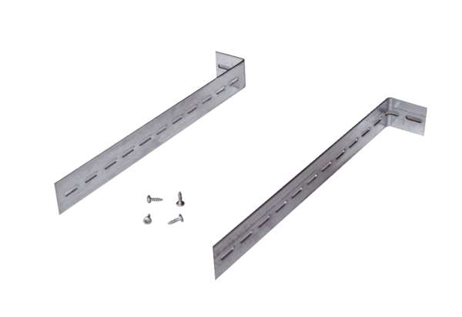Mounting support UPM 60/100Packing unit: 1 pieceRange: B
Article number: 0018.0010Manufacturer: MAICO

