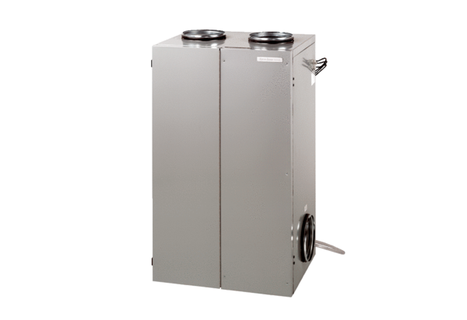Aeronom room air system WS 600Packing unit: 1 pieceRange: K
Article number: 0095.0056Manufacturer: MAICO

