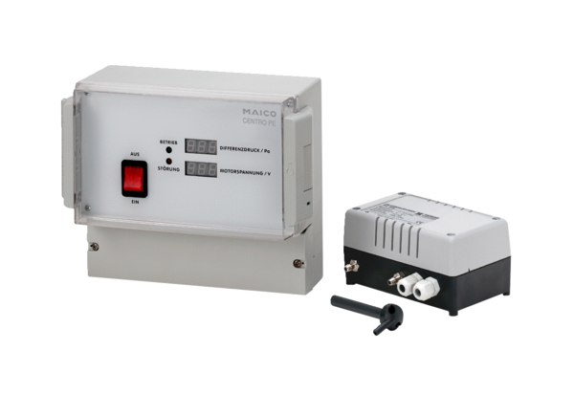Pressure controller Centro-PEPacking unit: 1 pieceRange: B
Article number: 0157.0398Manufacturer: MAICO

