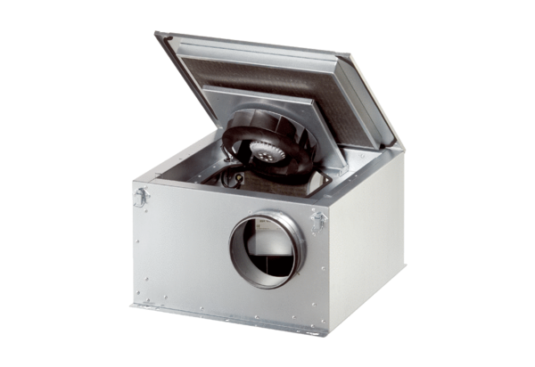Sound-insulated ventilation box ESR 20 ECPacking unit: 1 pieceRange: E
Article number: 0080.0086Manufacturer: MAICO

