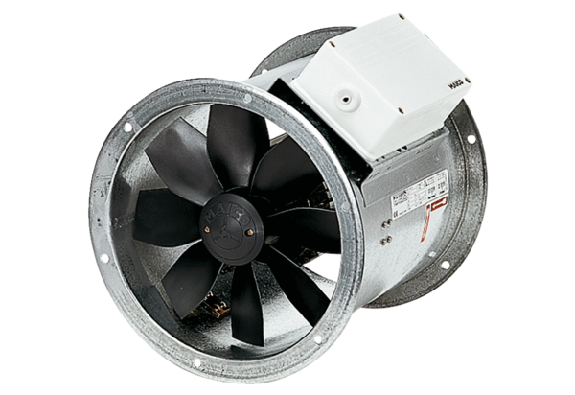Axial duct fan DZR 40/2 BPacking unit: 1 pieceRange: C
Article number: 0086.0061Manufacturer: MAICO

