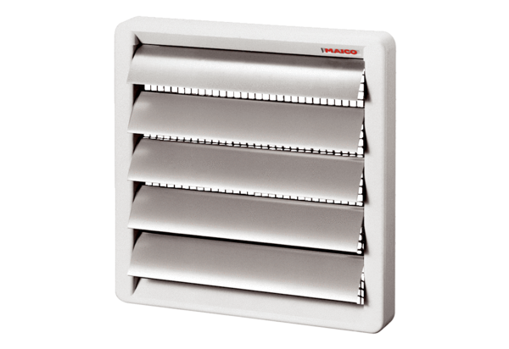Shutter, manual RS 30Packing unit: 1 pieceRange: C
Article number: 0151.0340Manufacturer: MAICO

