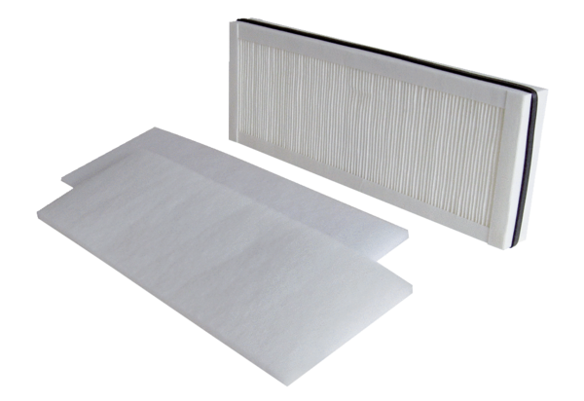Air filter, replacement WSF 250Packing unit: 1 set (3 pieces)Range: K
Article number: 0093.0890Manufacturer: MAICO

