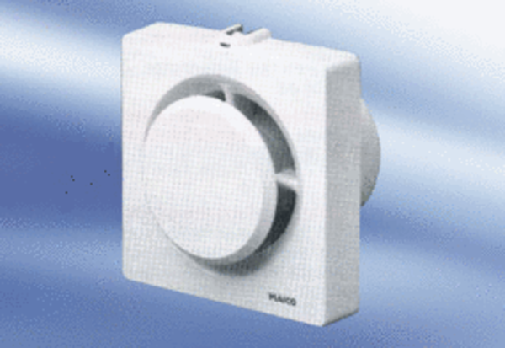Small room fan ECA 11-1 FPacking unit: 1 pieceRange:
Article number: 0080.0502Manufacturer: MAICO

