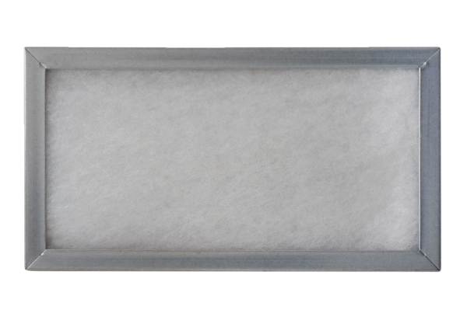Push-in frame for air filter WSG-ES 320/470Packing unit: 1 pieceRange: K
Article number: 0092.0561Manufacturer: MAICO

