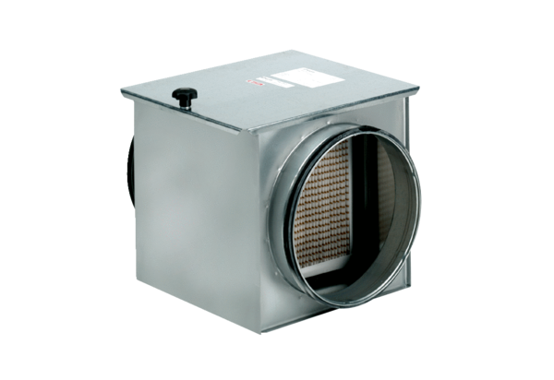Air filter TFE 15-5Packing unit: 1 pieceRange: C
Article number: 0149.0060Manufacturer: MAICO

