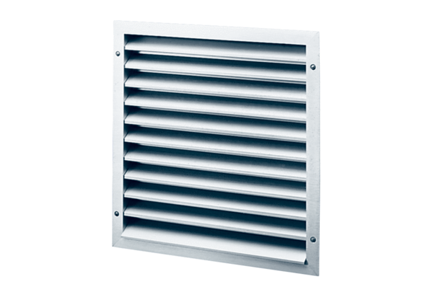External grille MLA 20Packing unit: 1 pieceRange: C
Article number: 0151.0111Manufacturer: MAICO

