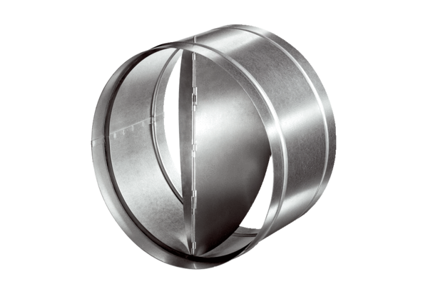Automatic backflow preventer AVM 31Packing unit: 1 pieceRange: C
Article number: 0093.0009Manufacturer: MAICO

