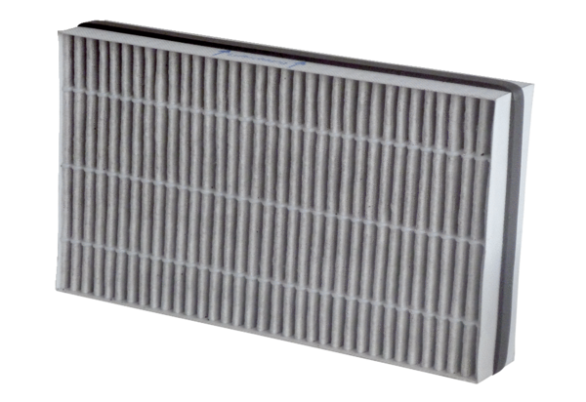Air filter, replacement WSF-AKF 300Packing unit: 1 pieceRange: K
Article number: 0093.1328Manufacturer: MAICO

