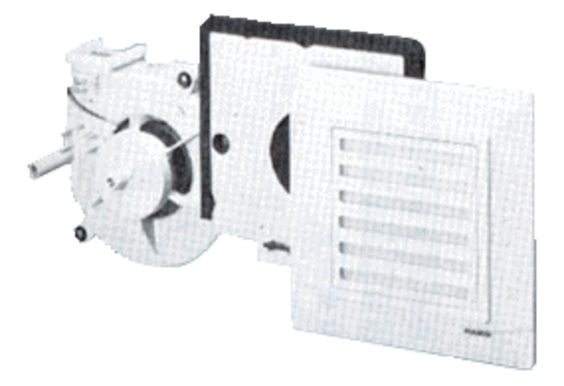Fan insert ER 17/60Packing unit: 1 pieceRange:
Article number: 0080.0735Manufacturer: MAICO

