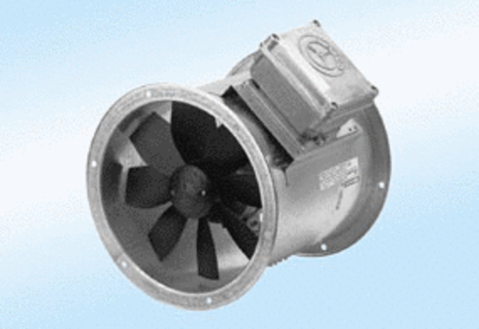Axial duct fan DZR 40/4 A-ExPacking unit: 1 pieceRange: C
Article number: 0086.0776Manufacturer: MAICO

