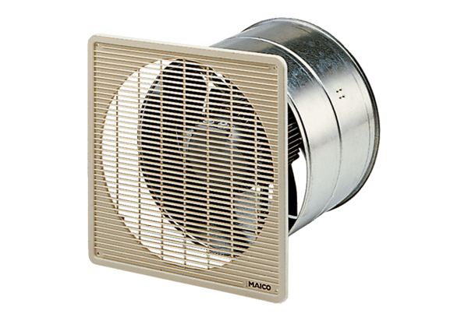DZF 45/4 BPacking unit: 1 pieceRange: C
Article number: 0085.0109Manufacturer: MAICO

