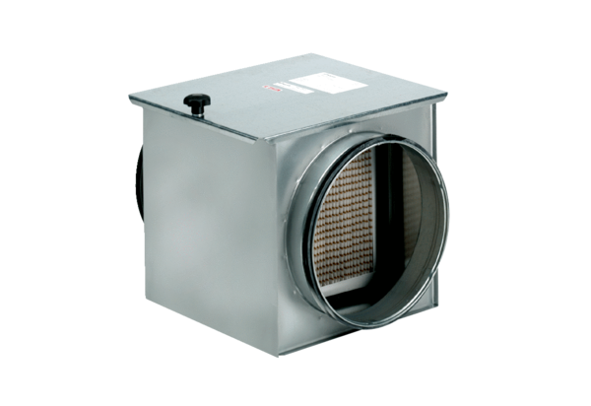Air filter TFE 12-7Packing unit: 1 pieceRange: C
Article number: 0149.0050Manufacturer: MAICO

