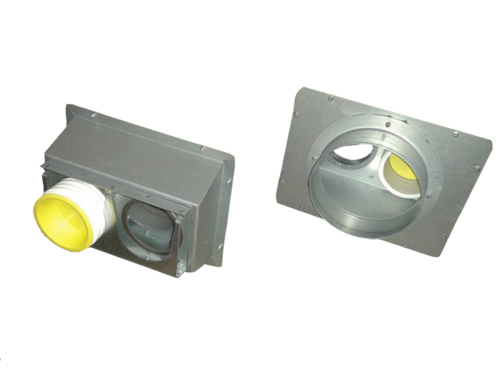Connection piece Trio AS75Packing unit: 1 pieceRange: K
Article number: 0017.0991Manufacturer: MAICO

