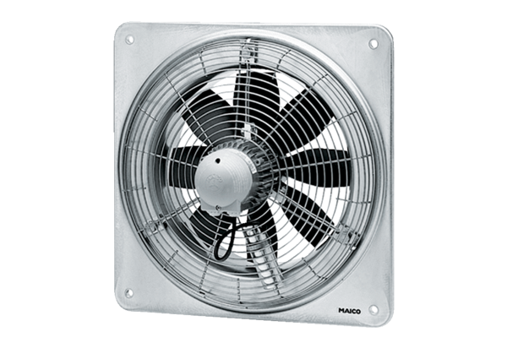Axial wall fan DZQ 45/4 BPacking unit: 1 pieceRange: C
Article number: 0083.0138Manufacturer: MAICO

