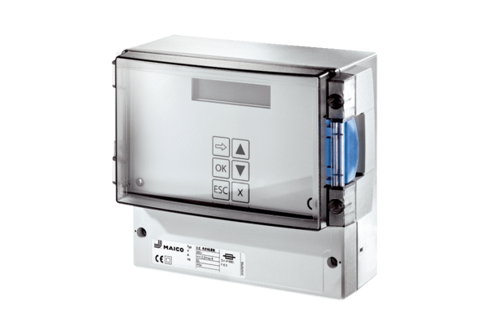Temperature control system EAT ECPacking unit: 1 pieceRange: E
Article number: 0157.0113Manufacturer: MAICO

