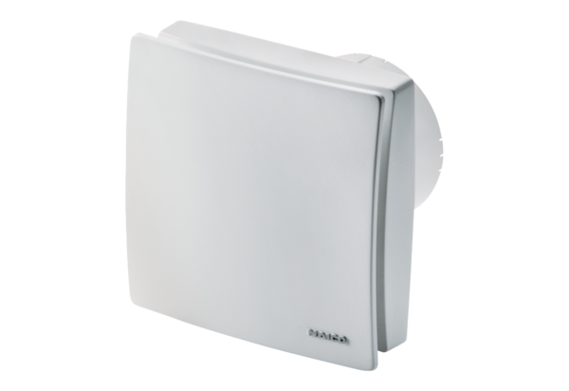Small room fan ECA 100 ipro KBPacking unit: 1 pieceRange: A
Article number: 0084.0209Manufacturer: MAICO

