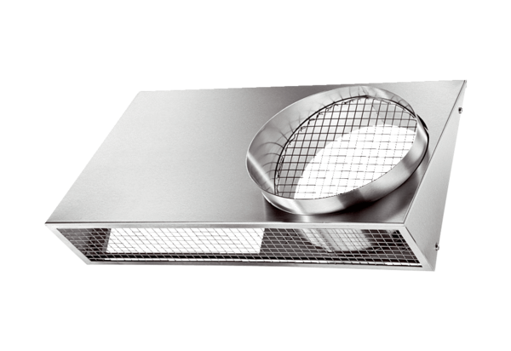Combi-wall connections KWH 16 LPacking unit: 1 pieceRange: K
Article number: 0152.0061Manufacturer: MAICO

