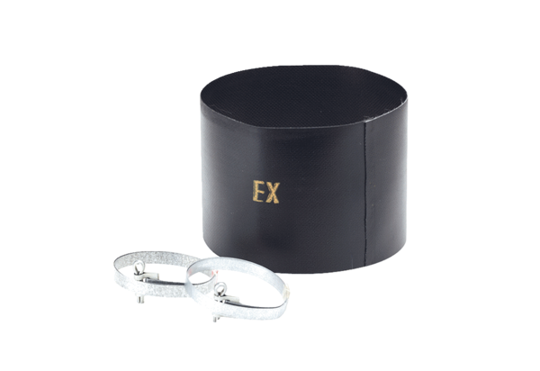Flexible cuff ELM 20 ExPacking unit: 1 pieceRange: C
Article number: 0092.0248Manufacturer: MAICO

