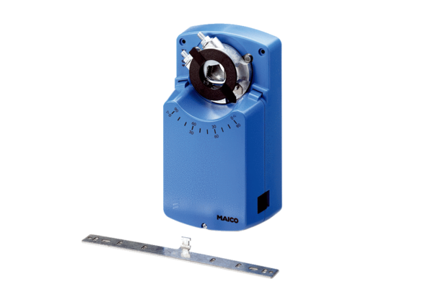Servomotor MS 8 PPacking unit: 1 pieceRange: C
Article number: 0157.0761Manufacturer: MAICO

