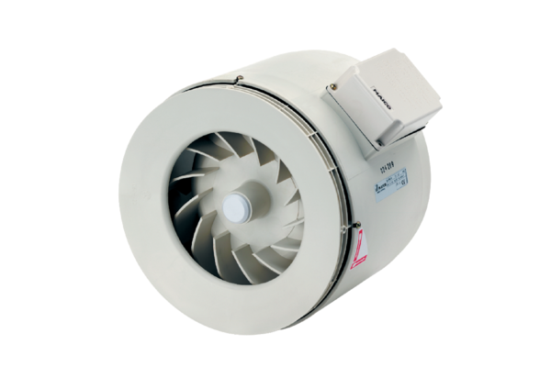Semi-centrifugal duct fan ERM 18Packing unit: 1 pieceRange: C
Article number: 0080.0251Manufacturer: MAICO

