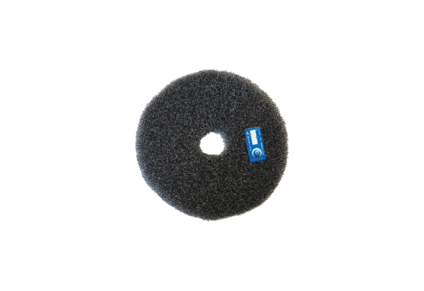Air filter, replacement ZF ECD+Packing unit: 2 piecesRange: B
Article number: 0093.1562Manufacturer: MAICO

