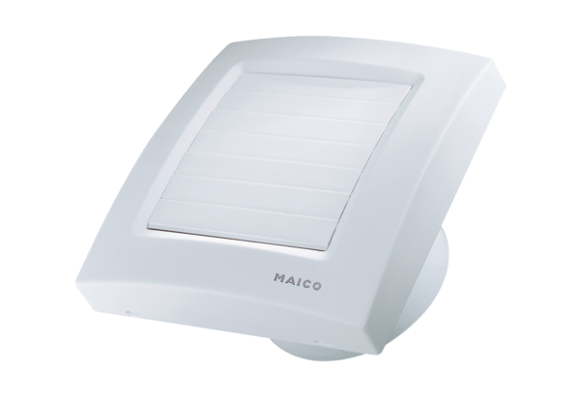Small room fan ECA 150 KPacking unit: 1 pieceRange: A
Article number: 0084.0015Manufacturer: MAICO

