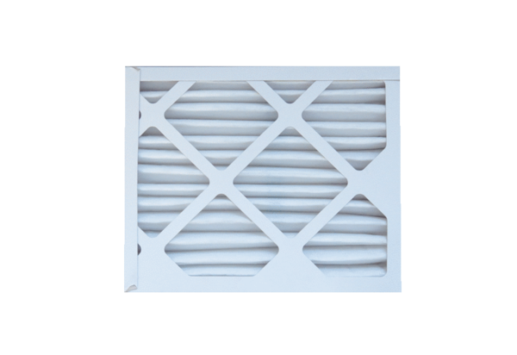Air filter, replacement ECR 25-31 EC M5Packing unit: 1 pieceRange: E
Article number: 0093.1524Manufacturer: MAICO

