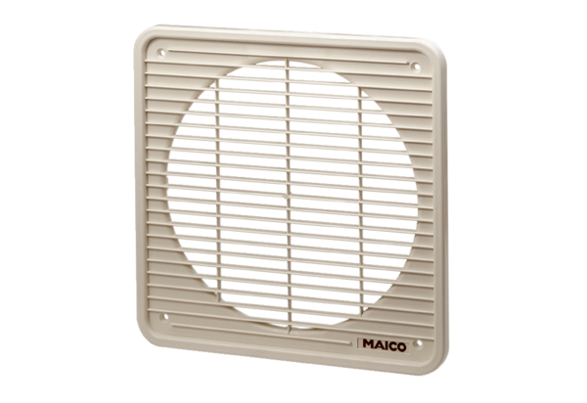Internal grille IG 20Packing unit: 1 pieceRange: C
Article number: 0059.0171Manufacturer: MAICO

