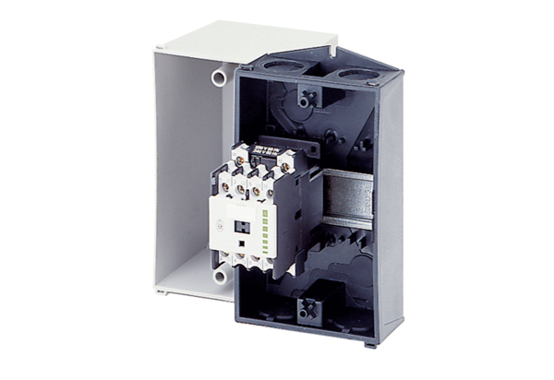Contactor US 16 TPacking unit: 1 pieceRange: C
Article number: 0157.0769Manufacturer: MAICO

