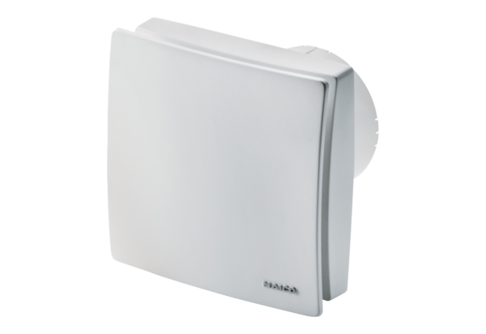Small room fan ECA 100 ipro KVZCPacking unit: 1 pieceRange: A
Article number: 0084.0206Manufacturer: MAICO

