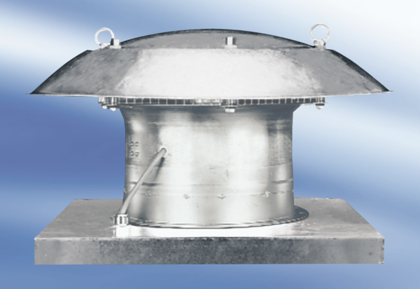Axial roof fan DZD 50/64 APacking unit: 1 pieceRange:
Article number: 0087.0450Manufacturer: MAICO

