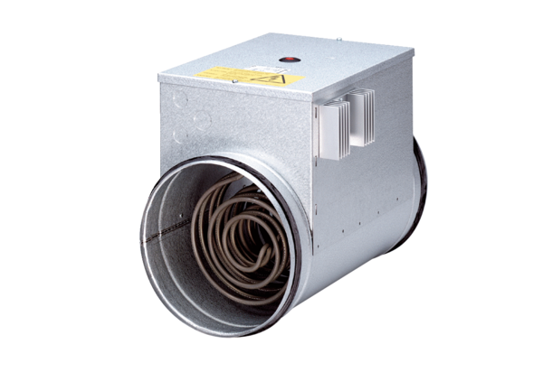Electrical air heater with controller DRH 16-5 RPacking unit: 1 pieceRange: C
Article number: 0082.0143Manufacturer: MAICO

