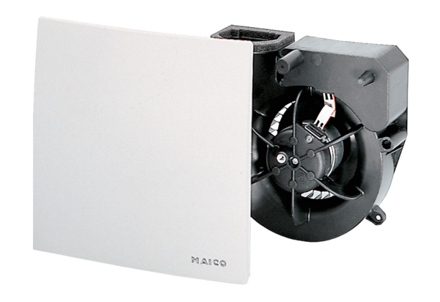Fan insert ER 60Packing unit: 1 pieceRange: B
Article number: 0084.0100Manufacturer: MAICO

