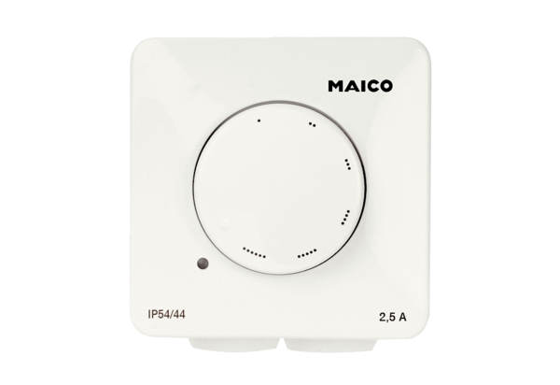Speed controller STX 1,5Packing unit: 1 pieceRange: C
Article number: 0157.1561Manufacturer: MAICO

