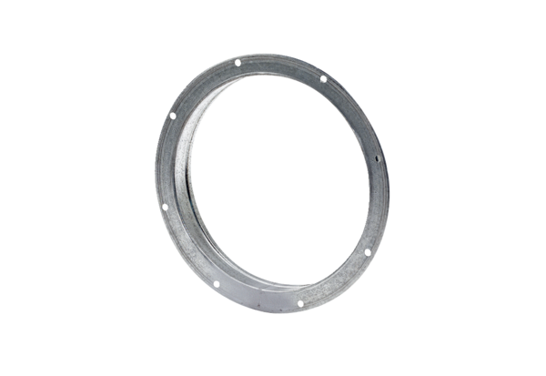Counter socket GS 60Packing unit: 1 pieceRange: C
Article number: 0055.0175Manufacturer: MAICO

