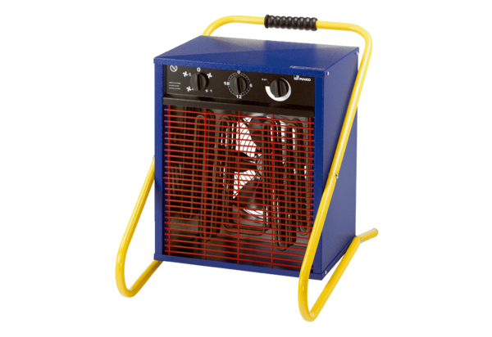Heater fan PHD 9Packing unit: 1 pieceRange: C
Article number: 0082.0067Manufacturer: MAICO

