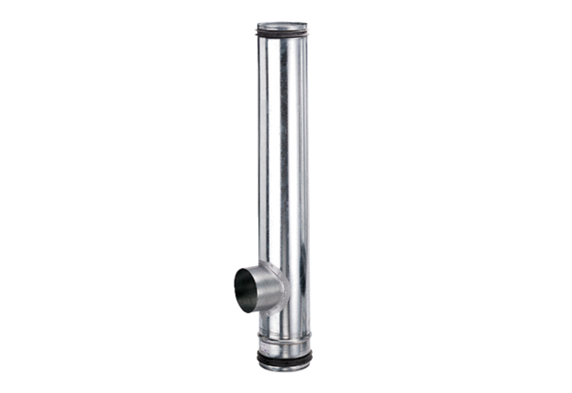Fire protection compensation element BA 125/100-1Packing unit: 1 pieceRange: B
Article number: 0093.1008Manufacturer: MAICO

