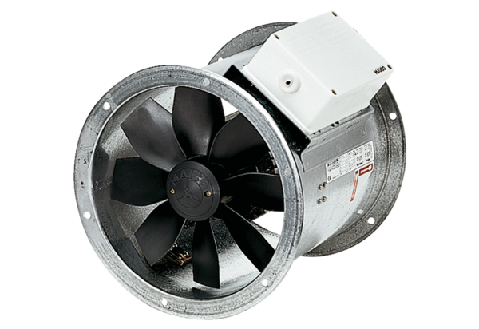Axial duct fan DZR 40/4 BPacking unit: 1 pieceRange: C
Article number: 0086.0030Manufacturer: MAICO

